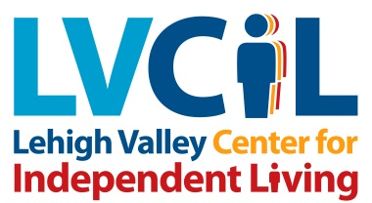
Some facts about LVCIL:
In the Fiscal Year ended 06/30/14, LVCIL served 622 unduplicated consumers. We’ve increased consumer base by 57% since offering transition services.
About 35% of consumers overall have physical disabilities, 23% have psychiatric disabilities, and 16% have cognitive disabilities.
Nearly 80% of consumers earn less than $20,000 annually; for 18%, it’s less than $5,000.
All transition services, which began in 2009, now represent the greatest number of hours worked in any services.
LVCIL is located in Allentown, PA, 65 miles from Philadelphia and 95 miles from New York City, and is in the third most populous area of PA. The area is a melting pot, with many cultures, and a very large number of Spanish Speaking residents. About 12% of the Valley are PWD’s.
LVCIL currently employs 37 individuals, and our 2014-2015 budget is $2,358,270.00; the agency reached the $1,000,000 in revenue mark in 2010. Our current budget represents 17 funding sources including federal, state, and local grants-funded programs, fee-for service income.

In addition to the four Core Services, LVCIL provides:

- Housing Search, Retention and Homelessness Prevention
- Supportive Services for Veterans Families
- ADA Information & Technical Assistance
- ADA Site Surveys
- Community Accessibility Program
- Sign Language Interpreter Referral Services
- S2L School to Adult Life Group
- Real World Lehigh Valley Transition Program
- Road to Graduation Transition Program
- Transition Advocacy Project

- Career Path Employment Services
- LIFE School-Based Services
- Adult Autism Waiver Supports Coordination
- Office of Long Term Living Waiver Supports Coordination
- Aging Waiver Supports Coordination
- Leadership In Schools Project
- Cross Disability Efforts
- Disability Sensitivity Education
- Transit Authority Complaint Intake and Investigation
- Consultation and Training

