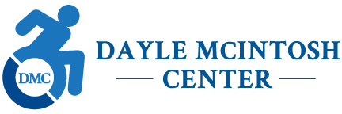

JOB OPPORTUNITIES, as of 12/28/20

The Dayle McIntosh Center is Orange County’s only Independent Living Center (ILC). DMC is a consumer-driven organization working to advance empowerment, equality, integration, and full participation of people with disabilities in the community. The majority of the staff at DMC are persons with disabilities. Current job opportunities include:

ADRC COMMUNITY TRANSITION COORDINATOR

The Aging and Disability Resource Connection (ADRC) of Orange County is an emerging collaborative of local senior and disability service agencies, led by the Dayle McIntosh Center and the Orange County Office on Aging. The goal of the ADRC is to streamline access to long-term services and supports, provide person-centered information and counseling services, and enable community-based living for Orange County seniors and residents with disabilities.

The ADRC Community Transition Coordinator provides information, supports consumers in decision making, and coordinates multiple services from a variety of organizations in order to successfully move older adults and individuals with disabilities from medical or residential facilities to community-based living options. This is a full-time, non-exempt position working remotely and from DMC’s Anaheim office. Compensation: $22/hour, full benefits.

Responsibilities:
- Conducts outreach to hospitals, nursing homes, & other residential facilities to identify individuals who want to transition back into the community;
- Using a person-centered approach, interviews consumers to ascertain immedicate and long-term needs for services;
- Develops consumer-driven transition plans in consultation with licensed care professionals;
- Coordinates transitions from medical and residential care facilities;
- Liaisons with community agencies in Orange County to arrange ancillary services and implement long-term services and supports.

Qualifications:
- Bachelor’s degree, two years’ experience working with individuals with disabilities, in health & human services, or as a case coordinator or equivalent education & experience;
- Demonstrated knowledge of essential services and benefits to facilitate community transition;
- Working knowledge of the Independent Living philosophy and methodology;
- Bilingual and/or ability to communicate in ASL is preferred.

