Appendix C: PR Files and Examples
We have provided additional Public Relation files and examples in our DVAO Center PR Examples and Files Folder.
In the folder you will find the following:
- Logos
- Photo Release Form
- Printables
- Introductory Language
- Eblast Examples
- Social Media Examples

Logos
You can download high-quality logos in .jpg, .pdf, and .png formats at the following hyperlink: https://www.dropbox.com/sh/4cvvuot8t1kgahd/AAAT03ROzGrrNdkvlidGCFyoa?dl=0
Logo Alt Text Description:
Always provide alt text for the logo when attaching to any document, or posting or a website, eblast, or on social media (as character limits allow).

Blue Text Logo:
Logo for Disability Vaccine Access Opportunity Center: White background with cobalt blue text. Large text reads "DVAO," with the right side of the letter V taking the form of a blue and white band-aid. Smaller text underneath reads "Disability Vaccine Access Opportunity Center."

White Text Logo:
Logo for Disability Vaccine Access Opportunity Center: Cobalt blue background with white text. Large text reads "DVAO," with the right side of the letter V taking the form of a blue and white band-aid. Smaller text underneath reads "Disability Vaccine Access Opportunity Center."

Photo Release Form
You access and download the photo release form at this link: https://www.dropbox.com/sh/4cvvuot8t1kgahd/AAAT03ROzGrrNdkvlidGCFyoa?dl=0

Printable Microsoft Templates
We have chosen Microsoft Powerpoint to create editable templates for postcards and flyers. You can add your CIL logo- space is provided in the bottom right corner.
Please note:
- Be sure to use the brand font and colors when creating.
- Important Note: when you add images or graphics to your flyer, including your logo, you must provide Alt Text. When you select the image, you will be given the opportunity to add alt text (you can right-click the image to do this—see the accessibility section of the toolkit for instructions).
- You can use these templates to create printed as well as digitally accessible PDFs.
- These are samples and you aren’t required to use these.
- Important note when using photos of your vaccine champions: It is always best practice to have your interviewee sign a photo release, should you use their image. A photo release protects you and the person photographed. You will find the photo release form in the PR toolkit folder.
- Important note on disclaimers: in the printables, you will find a disclaimer that is required for all print materials that include the DVAO Center logo or reference grant award.
- Per DVAO Toolkit- Publications: All publications and communications that include the DVAO Center logo or reference grant award (statements, toolkits, resource guides, blog posts, websites, presentations, etc.) produced under a federal award must bear the acknowledgment of federal assistance using the following statements below. A final draft must be submitted for review and approval to your Grants Manager, for review of federal language and adherence to award regulations, prior to print and dissemination. For publications produced by subrecipients and contractors, the Program Officer should provide content review and the Grants Manager provides review of incorporation of federal language and adherence to any required award regulations. Please reach out to DVAO for approval on any materials that require the use of the following statement. Please include in all printed publications that include the DVAO Center logo or reference grant award:
  - This [publication/program, etc.] [is/was] supported by the Centers for Disease Control and Prevention of the U.S. Department of Health and Human Services (HHS) as part of a financial assistance award totaling $XX with 100 percent funded by CDC/HHS. The contents are those of the author(s) and do not necessarily represent the official views of, nor an endorsement, by CDC/HHS, or the U.S. Government.

Brand Font: Lato
Brand Colors: White, Cobalt Blue #004aad
To access the printable documents, please click the following hyperlink: https://www.dropbox.com/sh/4cvvuot8t1kgahd/AAAT03ROzGrrNdkvlidGCFyoa?dl=0

Introductory Language Suggestions
Language you can use to announce your partnership and what it means is provided with instructions on where to use it. You will find the introductory language template below.
Example Introductory Language
Use this when introducing the DVAO center on your website, on social media, or in your announcement eblast to followers of your organization.
People with disabilities are at the greatest risk of severe illness and death from COVID-19. Because of this fact, (Insert Name of your CIL) has partnered with the Disability Vaccine Access Opportunities Center (DVAO Center), a national center that provides resources, training, and technical assistance to address vaccine hesitancy and barriers for people with disabilities. The DVAO Center will assist us in furthering our efforts to assist people with disabilities who may have specific disability-related questions and barriers with getting the COVID-19 vaccination.
(Insert Name of your CIL) will connect with health departments and other local agencies responsible for vaccine distribution and training and technical assistance provided through the DVAO Center. Our goal is to bring vaccination opportunities to everyone, and to remove the barriers that prevent people with disabilities from equitable vaccine access.

Eblasts or Mass Email Suggestions
Eblasts, or mass emails, can be used to send information to your community all at once. Below you will find some tips for creating and writing the eblasts. You will also find example eblast templates following the instructions below.
Writing Eblasts or Mass Emails:
- You can use the Frequently Asked Questions provided in your overall toolkit to create content for social media, eblasts, or flyers and postcards.
- Our greatest advice is that you interview your local community who are champions of the vaccine and booster shot. Get quotes from them about why they chose to get vaccinated. These personal stories are what work best when convincing others, particularly people with disabilities and their care providers or families. You can add the stories to social media, in eblasts, or even record the interviews to post videos online.
- Most importantly, listen to your community and build your strategy off of what they say they need!
- Important note: Remember, when creating content, it is important to remind readers that people with disabilities are at the greatest risk of severe illness and death from COVID-19. Stating this clearly can help dispel any trolls (combative persons) you may experience. They are most likely unaware of the facts and how the vaccine has saved lives!
Don’t forget these important steps when writing your eblasts:
- If providing images, always include alt text or image descriptions as best practice.
  - Important note on gender inclusion: While centering the goal of helping people with disabilities get vaccinated, it is necessary to also be inclusive of people of all genders, including those you may interview and when writing content. Please review the “gender inclusion” subheading under “incorporating intersectionality and health equity” for helpful information on how to respectfully include gender identity in your interviews and content creation.
  - Important note when using photos of your vaccine champions: It is always best practice to have your interviewee sign a photo release, should you use their image. A photo release protects you and the person photographed. You will find the photo release form in the PR toolkit folder.
- Have another coworker with a talent for editing review your eblast for grammar and spelling.
- Try not to overwhelm your readers with too much information or too many emails. One to two emails a month about this campaign should be enough for the average reader to consume. Of course, this may change if new information about COVID-19 or the vaccine is released.
- Before providing outside resources, ensure they are accessible.

Sample Eblasts
The following sample eblasts can be used and modified.

DVAO Introduction Eblast
Use this text to introduce your partnership with the DVAO center via eblast to followers of your organization.
(Insert Name of your CIL) has partnered with the Disability Vaccine Access Opportunities Center (DVAO Center), a national center that will further vaccination access for people with disabilities. The DVAO Center will assist us in furthering our efforts to aid people with disabilities who are our local CIL constituents by combating hesitancies and barriers people with disabilities are facing regarding COVID-19 and vaccine access.
(Insert Name of your CIL) will connect with health departments and other local agencies responsible for vaccine distribution and training and technical assistance provided through the DVAO Center. Our goal is to bring vaccination opportunities to everyone and to remove the barriers that prevent people with disabilities from equitable vaccine access.
(You may insert some personal goals and expected achievements of your CIL through the DAVO center here)
Funding for this effort is supported by the Centers for Disease Control and Prevention of the U.S. Department of Health and Human Services (HHS) as part of a financial assistance award with 100 percent funded by CDC/HHS. The contents are those of the author(s) and do not necessarily represent the official views of, nor an endorsement, by CDC/HHS, or the U.S. Government.

DVAO Community Vaccine Champions Eblast 1
Use this example to lead you in how to tell your community about local vaccine champions with disabilities via eblast to followers of your organization.
The holidays are fast approaching, and for many of us, that means eagerly looking forward to time with friends, family, and loved ones. Don’t let your anticipation for shared meals, gift exchanges, and other festive fun keep you from remembering just how important it is to protect those we love, particularly those with disabilities and/or underlying health conditions. One of the best ways we can do this is by getting our COVID-19 vaccine or booster shot before spending the season together.
In this month’s newsletter, we spend some time with Wynee Fair. Wynee is a member of the Black community who is committed to protecting her family. That’s why she chose to get the COVID-19 vaccine.
Fair also has a psychiatric disability. When she heard about the COVID-19 vaccine, she didn’t hesitate to get it. Her family is diabetic, and Fair knew that getting the shot would help her protect them.
“I trusted the vaccine,” Fair said.
Fair recently lost a family member to diabetes. It’s more important now than ever to her that she and her family protect themselves, each other, and their health.
She has tried to convince her son to get his COVID-19 vaccine, but he remains skeptical. He, like many others, is concerned about the speed with which the vaccine was created. Fair won’t give up though, remaining determined to protect him.
“Trust the numbers,” Fair said when asked what she’d say to encourage others to get their COVID-19 vaccine.
To protect your family and those you love, talk to your doctor, or another trusted medical provider, about if the COVID—19 vaccine and booster shot are right for you. You can also contact (Insert Name of your CIL and contact information).
Disclaimer:
The staff of (Insert Name of your CIL) are not licensed, medical providers. They are unable to offer medical advice about the best vaccine for you or predict how the vaccine may affect you or your family.

DVAO Community Vaccine Champions Eblast 2
Use this example to lead you in how to tell your community about local vaccine champions with disabilities via eblast to followers of your organization.
This month’s newsletter will focus on a member of the BIPOC community with a disability who’s chosen to receive the COVID-19 vaccine. We highlight these stories in hopes they’ll help others who are considering the shot to make informed and confident decisions.
Jonathan Brown is a member of the BIPOC community with a disability, caused by a stroke. Because of this medical history, Brown was hesitant to receive his COVID-19 vaccine, but he decided to talk with his doctor to learn more.
“She insisted I get it,” Brown said.
Ultimately, Brown did get his shot, knowing he wanted to protect members of his family and community. He especially wanted to protect his mom, who he attempted to convince to get a vaccine.
Brown’s mom received a mandate from her employer that she’d need to either get a vaccine or risk losing her job.
“She’s worked her job for forty years,” Brown explained. “It makes her smile, and I love to see her smile, so I tried to tell her to get it.”
Ultimately, Brown’s mom chose not to get the vaccine, leaving her job behind. However, Brown isn’t done with trying to convince her yet.
“What do you have to lose?” Brown said when asked what he would say to others who were hesitant about getting the vaccine. “You either get the shot, or you get COVID.”
If you’re considering the COVID-19 vaccine but are feeling hesitant, reach out to your doctor or another medical professional you trust to find out which shot is best for you.
You can also contact (Insert Name of your CIL and contact information).
Disclaimer:
The staff of (Insert Name of your CIL) are not licensed, medical providers. They are unable to offer medical advice about the best vaccine for you or predict how the vaccine may affect you or your family.

DVAO Informational Eblast
Use this example to lead you in how to tell your community about vaccine information resources, including your own!
In this month’s newsletter, we’re going to focus on a variety of resources offering help with vaccines and information related to the COVID-19 pandemic. This list is designed to help you find information, answers, and even free or discounted transportation to vaccine sites.
General Information Resources:
- For detailed information about the rate of COVID vaccines among the disability population, you can visit The CDC COVID-19 disability data tracker.
- The COVID-19 misinformation alert page from the Public Health Communications Collaborative offers explanations for the most common vaccine misinformation on social media. So, before you get nervous about the latest vaccine myth, consider searching for it in this great resource.
- These videos from the Georgia Tech Center for Inclusive Design and Innovation offer easy to understand tips about protecting yourself and your loved ones from COVID-19
Transportation Resources:
- (Insert local resources or resources you’re providing here).
Your CIL’s/local Resources:
- (Insert local resources or resources you’re providing here).
To protect your family and those you love, talk to your doctor, or another trusted medical provider, about if the COVID—19 vaccine and booster shot are right for you. You can also contact (Insert Name of your CIL and contact information).
Disclaimer:
The staff of Insert Name of your CIL are not licensed, medical providers. They are unable to offer medical advice about the best vaccine for you or predict how the vaccine may affect you or your family.

Social Media Suggestions
- You can use the Frequently Asked Questions provided in your overall toolkit to create content for social media, eblasts, or flyers and postcards.
- Important note on gender inclusion: While centering the goal of helping people with disabilities get vaccinated, it is necessary to also be inclusive of people of all genders, including those you may interview and when writing content. Please review the “gender inclusion” subheading under “incorporating intersectionality and health equity” for helpful information on how to respectfully include gender identity in your interviews and content creation.
- Important note when using photos of your vaccine champions: It is always best practice to have your interviewee sign a photo release, should you use their image. A photo release protects you and the person photographed. You will find the photo release form in the PR toolkit folder.
- Important note: Remember, when creating social media content it is important to remind readers that people with disabilities are at the greatest risk of severe illness and death from COVID-19. Stating this clearly can help dispel any trolls (combative persons looking to “fight” your work in the comments or private messaging) you may experience.

Canva Templates
Canva is a free, online tool you can use to create social media content. We have provided two templates that can guide you:
- Social Media Post template
- I got my vaccine because
Important Note: when you download your creations from Canva, they will not be readily accessible. You must provide alt text or image descriptions for the graphics you create.

Other Notes on Social Media Templates and Posting
- The DVAO logo in white and blue varieties are within the template.
- You can add your CIL logo as well. Space is provided in the bottom right corner.
  - To add your CIL logo, simply upload your logo in PNG form with a transparent background, or as a JPG, whichever works best for you. You will then find your logo in your uploaded files, where you can drag and drop the logo onto your graphic.
  - If you have a Canva premium account, you can save your brand logo and colors! Canva also provides tutorials on how to use the platform, should you need.
- Be sure to use the brand font and colors when creating your social media graphics posts.
- Don’t forget about character limits! Twitter limits you to 280 characters. Facebook limits you to 2,000 characters. Instagram limits you to 2,200 characters.
  - When publishing directly, Twitter limits alt text to 1,000 characters. There is no limit to alt text on Facebook or Instagram.
  - If you use a social media manager like Hootsuite, Hootsuite will limit your alt text!

Social Media Post Examples with Alt Text:
We have provided two templates to guide you:
- Social Media Post template
- I got my vaccine because
- Important Note: when you download your creations from Canva, they will not be readily accessible. You must provide alt text for the graphics you create.
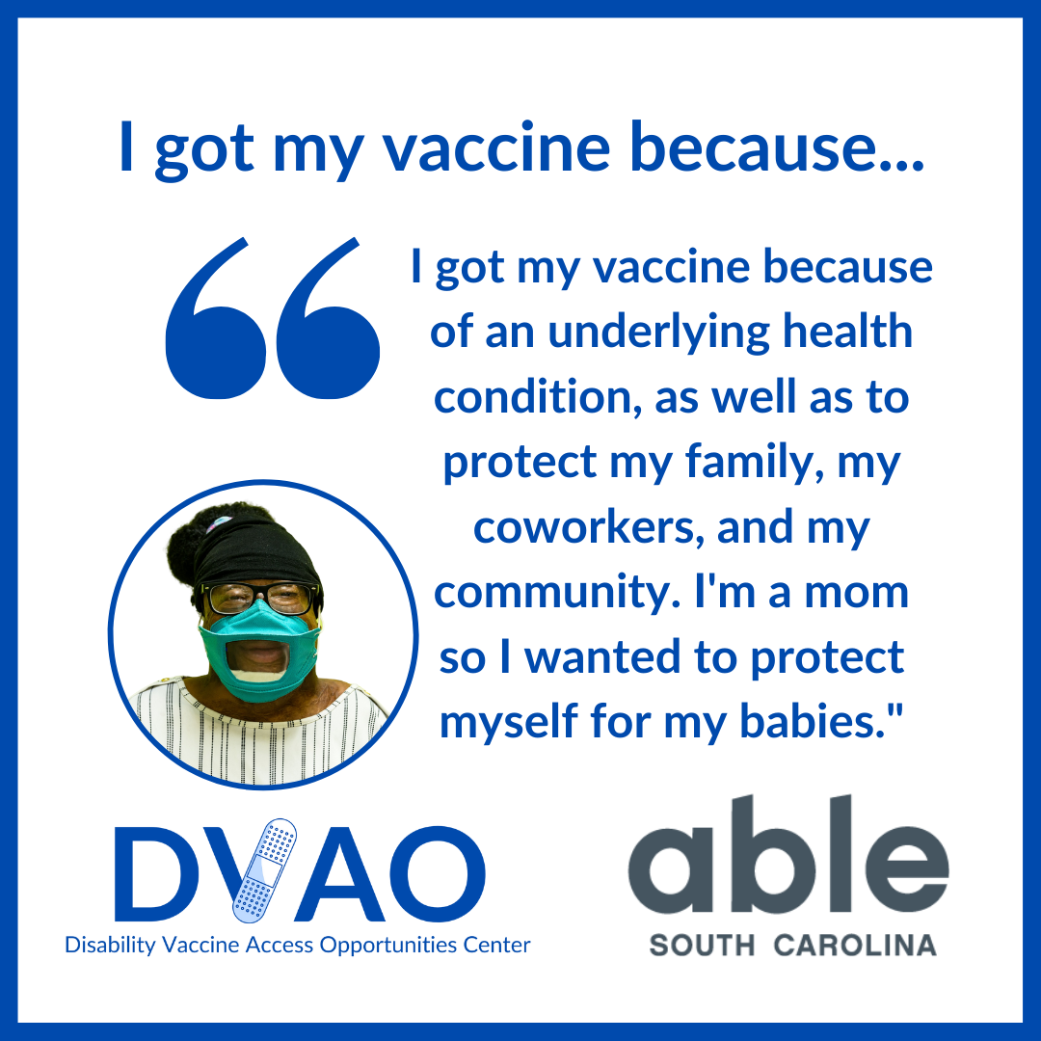
Post Text for Facebook or Instagram: Vaccine Champions with disabilities live in your community! Laquanda Clark is a person living with disabilities. She shared with us why she chose to get vaccinated against COVID-19, “I got my vaccine because of an underlying health condition, as well as to protect my family, my coworkers, and my community. I'm a mom so I wanted to protect myself for my babies."
We can help you make your plan to get vaccinated today!

Post Text for Twitter: Laquanda Clark is a person with disabilities. She chose to get the COVID-19 vaccine, “I got my vaccine because of an underlying health condition, as well as to protect my family, my coworkers, and my community. I'm a mom so I wanted to protect myself for my babies."
Image Description and Alt Text: Graphic with white background and cobalt blue border. Image of a Black woman with disabilities, smiling while wearing a face-view mask in a blue-bordered circular frame appears in the bottom left corner. Blue text that occupies the graphic reads, ‘I got my vaccine because… I got my vaccine because of an underlying health condition, as well as to protect my family, my coworkers, and my community. I'm a mom so I wanted to protect myself for my babies.’ Disability Vaccine Access Opportunities Center and Able South Carolina logos appear at the base of the graphic.
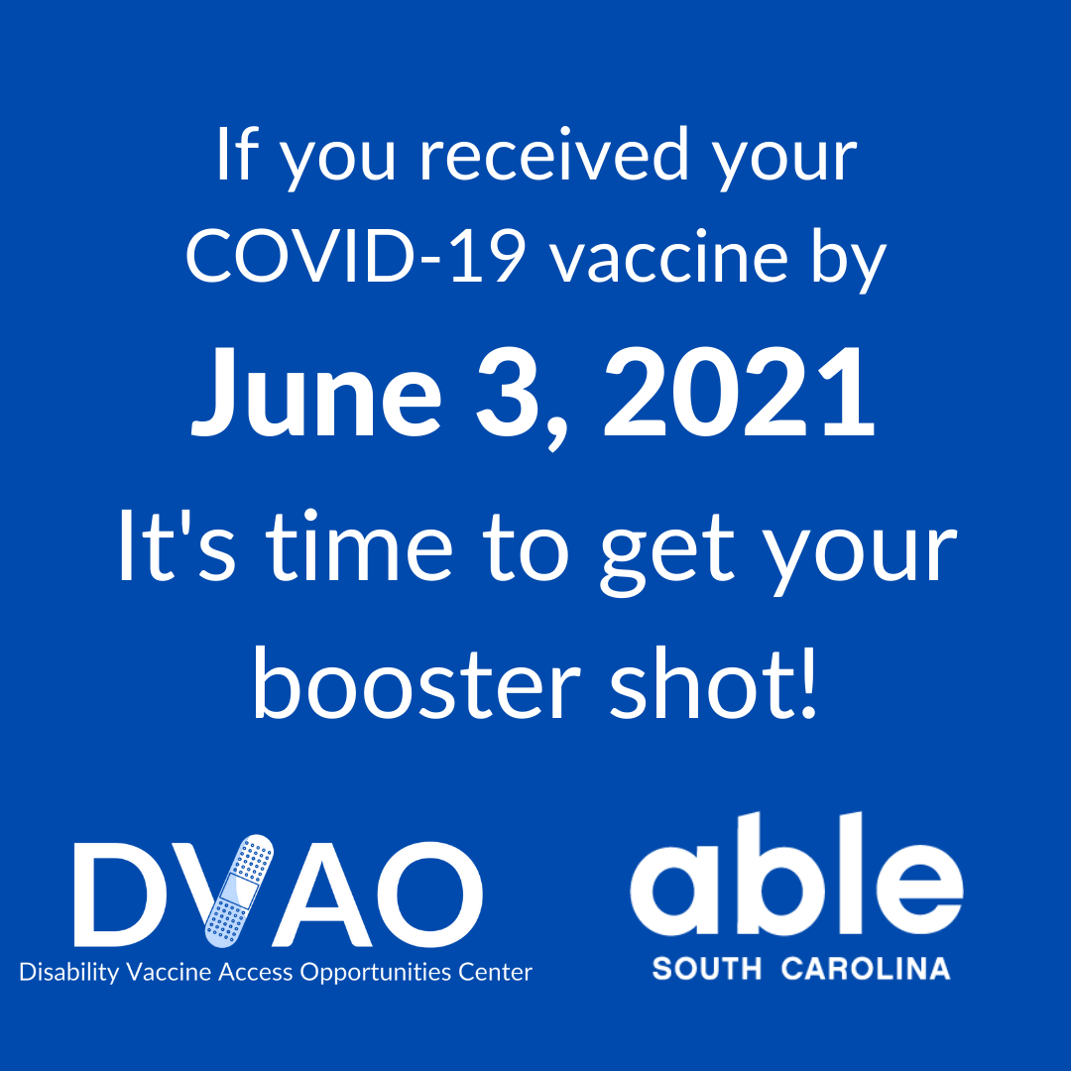
Post Text for Facebook or Instagram: Have you already received your COVID-19 vaccine? Great! You are doing your part to protect your community. But don’t forget about the importance of booster shots! The COVID-19 booster shot is a dose of the vaccine that will make sure your first vaccine is strong for a longer amount of time. Booster shots can also better protect you from COVID-19 variants, like Delta and Omicron. It’s more important than ever that we all get booster shots. If you received your original COVID-19 vaccine by June 3, 2021, it’s time to get your booster shot!
We can help you make your plan to get vaccinated or get your booster shot today!
Post Text for Twitter: Don’t forget about the importance of booster shots! Because of virus variants, it's more important than ever to get your booster shot. If you received your original COVID-19 vaccine by June 3, 2021, it’s time to get your booster shot! We can help you make your plan!

Image Description and Alt Text: Graphic with cobalt blue background and white text that reads, ‘If you received your COVID-19 vaccine by June 3, 2021, it’s time to get your booster shot! Disability Vaccine Access Opportunities Center and Able South Carolina logos appear at the base of the graphic.

